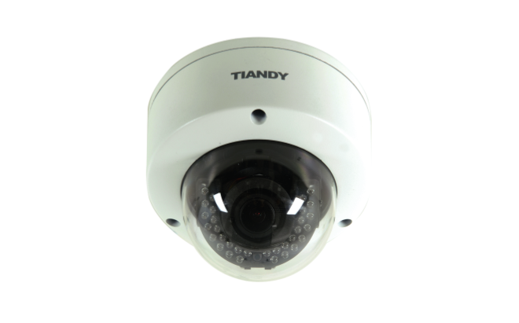

Features

• H.265 Codec  
• Up to 2048X1536 High Resolution  
• 50Hz: 25fps (2048×1536), 50fps (1920×1080)  
• 60Hz: 30fps (2048×1536), 60fps (1920×1080)  
• WDR, 3D DNR, HLC  
• Triple Streams  
• Smart VQD(Video Quality Diagnosis)  
• Smart Facial Detection  
• 19 kinds of IVA Functions  
• Smart IR  
• Defog  
• Motorized Lens  
• On-board Storage, up to 64GB  
• Built-in Interface  
• Built-in all Interfaces, Including Alarm I/O 2/1, Audio I/O 1/1, Ethernet, CVBS, 485/232, MicroSD 64G Card, USB  
• TVS 6000V, Lightning/Surge 2000V Protection, IP66, IK10

Specification

|  |  |
| --- | --- |
| **Image Sensor** | 1/2.8″ Sony Exmor CMOS |
| **Core Processor** | Cortex A7 Architecture processor |
| **Operating System** | Embedded Linux |
| **Signal System** | PAL/NTSC |
| **Min. Illumination** | Color: 0.05 Lux @(F1.2, AGC ON) |
| B/W: 0.01Lux @(F1.2, AGC ON); 0 Lux with IR |
| **Shutter Time** | 1/100000s～1s |
| **Lens** | 2.8-12mm, Motorized Lens |
| **Lens Mount** | Φ14 |
| **Auto Iris** | Y |
| **Adjustment Range** | Pan:0° – 355°, Tilt: 0° – 75°, Rotation: 0° – 355° |
| **Day& Night** | Dual ICR |
| **Wide Dynamic Range** | 120 dB |
| **Digital Noise Reduction** | 3D DNR |
| **Focus** | One-key Autofocus/Manual |
| **Compression Standard** | |
| **Video Compression** | H.265/H.264/MJPEG |
| **Bit Rate** | 32Kbps~16Mbps |
| **Audio Compression** | G.711/AAC/ADPCM |
| **Bit Rate** | 8K~48Kbps |
| **Image** | |
| **Max. Image Resolution** | 2048×1536 |
| **Frame Rate** | 50Hz: 25fps (2048×1536), 50fps (1920×1080) |
| 60Hz: 30fps (2048×1536), 60fps (1920×1080) |
| **Triple Stream** | Mainstream: 3MP(2048×1536) |
| Substream: D1(704*576) |
| 3rd Stream: D1(704*576) |
| **Image Settings** | Configurable Brightness, Saturation, Contrast,Flip Mode |
| **HLC** | Y |
| **Smart Defog** | Y |
| **Corridor** | Y |
| **EIS** | Y |
| **ROI** | 4 Zones |
| **Privacy Mask** | 4 Zones |
| **Picture Overlay** | 200 × 200, BMP 24bit, Zone Configurable |
| **Network** | |
| **Browser** | IE 7+, Chrome 18 +, Firefox 5.0 + |
| **Network Storage** | NAS |
| **Video Analytics** | Tripwire/Perimeter/Facial detection/People Counting/ Missing&Foreign object/Crowd/Loitering/Fast Moving/Parking/Off-position/Blurred Image/Audio Offline/Screaming Detection |
| **Alarm Trigger** | Motion Detection/IP Conflict/MAC Conflict/Port Alarm |
| **Protocols** | TCP/IP/ICMP/HTTP/HTTPS/FTP/DHCP/DNS/  DDNS/RTP/RTSP/RTCP/PPPoE/NTP/UPnP/  SMTP/SNMP/IGMP/802.1X/QoS/IPv6/Bonjour |
| **User Permission** | 4 Level/8 Users |
| **Remote Connection** | 7-ch Access |
| **System Compatibility** | ONVIF (Profile S), SDK |
| **Interface** | |
| **Audio Input** | 1-ch 3.5 mm Audio Interface, MIC IN/LINE IN |
| **Audio Output** | 1-ch 3.5mm Audio Interface (line level, 600 Ω) |
| **Communication Interface** | 1-ch RJ45 10M / 100M Ethernet interface and 1-ch RS-485 Interface |
| **Alarm Input** | 2-ch |
| **Alarm Output** | 1-ch |
| **Video Output** | 1-ch Vp-p Composite Output (75 Ω, BNC) |
| **On-board Storage** | Built-in Micro SD/SDHC/SDXC Card Slot, up to 64 GB |
| **Extension** | 1x USB2.0 |
| **General** | |
| **Operating Conditions** | -35℃～60℃, 0～95% RHG |
| **Power Supply** | DC 12V±10% AC 24V±10%, PoE (802.3af) |
| **Power Consumption** | 4.5 W (IR OFF), 8.5W (IR ON) |
| **Circuit Protection** | TVS 6000V, Lightning/Surge 2000V Protection |
| **Impact Protection** | IP66, IK10 |
| **IR Range** | 30M |
| **IR LEDs** | 32pcs |
| **Dimensions** | 150mm×150mm×122mm |
| **Weight** | 1.5kg (IP Camera Only), 1.7kg (with Packing Box) |

Dimension

[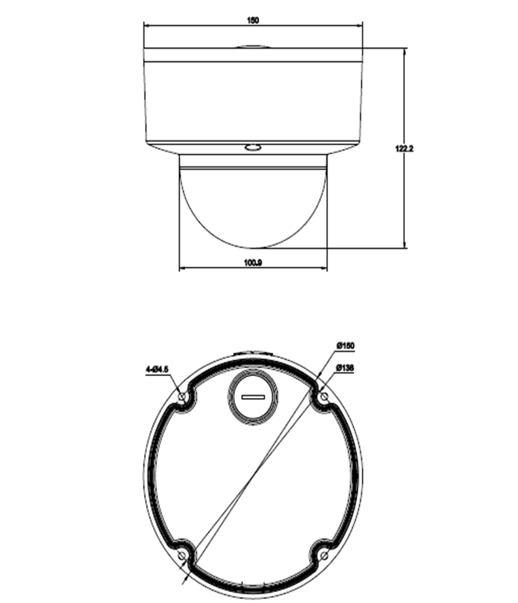](http://en.tiandy.com/wp-content/uploads/2015/07/666.png)